Project Report

Title- Punctuality Intelligence Dashboard

Under the guidance of:

Dr. Santosh Kumar Sahu

Sr. Programming Officer

GEOPIC, ONGC, Dehradun



Submitted by: Khushi Papola

and Vaidehi Thapliyal

MBA AI-DS, GEU, Dehradun

DECLARATION

I here by declare that the work presented in this project report entitled “Punctuality Intelligence Dashboard” is an original record of the work carried out by me during my Summer Internship at GEOPIC, ONGC, Dehradun, from 23/06/25 to 23/08/25, under the guidance of Dr. Santosh Kumar Sahu( Sr. Programming Officer GEOPIC, ONGC, Dehradun.

CERTIFICATE

This is to certify that Khushi Papola and Vaidehi Thapliyal, pursuing Masters of Business Administration in Artificial Intelligence and Data Science from Graphic Era University, Dehradun, has successfully completed Summer Internship for the period starting from 23-06-25 to 23-08-25 at GEOPIC, Oil and Natural Gas Corporation Limited, Dehradun.
The project work entitled “Punctuality Intelligence Dashboard” embodies the original work carried out by him under the guidance of Dr.. Santosh Kumar Sahu, Sr. Programming Officer, GEOPIC, ONGC, Dehradun.

SIGNATURE:
Dr. Santosh Kumar Sahu(
Sr. Programming Officer
GEOPIC, ONGC, Dehradun)


ACKNOWLEDGEMENT

I would like to express my deepest gratitude to ONGC GEOPIC, Dehradun, for providing me with the invaluable opportunity to undertake this summer internship. This experience has significantly enriched my understanding of Large Language Models and full-stack development of a scalable Applicant Tracking System (ATS), as applied in a real-world organizational environment. I am immensely indebted to my project guide, Mr. DAVINDER SINGH, GM (Programming), for his exceptional mentorship, unwavering support, and insightful guidance throughout the duration of this project. His expertise and encouragement were instrumental in helping me navigate the intricacies of this work and fostering my growth as a cybersecurity professional.
I am also grateful for access to the state-of-the-art workstation, which played a crucial role in facilitating the execution, hands-on experimentation, and successful completion of this project. I feel fortunate to have worked with such powerful resources that enabled detailed attack simulations, packet captures, and reverse engineering tasks.
Finally, I extend my heartfelt appreciation to Graphic Era Hill University, Dehradun, for providing me with this opportunity to engage in industry-relevant training, deepen my practical skills, and contribute meaningfully to a forward- looking cybersecurity initiative.

Khushi Papola
Graphic Era University, Dehradun

Abstract
The internship at the Geodata Processing and Interpretation Centre (GEOPIC), Oil and Natural Gas Corporation Limited (ONGC), Dehradun, was undertaken from 23rd June to 23rd August as part of the MBA in Artificial Intelligence and Data Science program. The objective of the internship was to apply data analytics and visualization techniques to enhance HR operational efficiency by analyzing employee attendance records through Power BI.
The project focused on the attendance data of 161 GEOPIC employees over a two-month period. The raw data, collected from the biometric punch-in and punch-out system, was initially available in Excel format. It was thoroughly cleaned, standardized, and transformed to remove inconsistencies, filter out holidays, and isolate records of GEOPIC employees only. Key performance indicators (KPIs) such as punctuality rate, absenteeism percentage, average working hours, and punch behavior (single vs. double punch) were derived.
A fully automated, interactive Power BI dashboard was then developed to visualize and monitor these metrics. The dashboard was integrated with an automated data refresh mechanism—allowing new attendance files placed in a specified folder to be dynamically updated in Power BI without manual intervention. This significantly reduced reporting time and improved data accessibility for HR and administrative teams.
The dashboard enabled management to track punctuality trends, identify frequent latecomers, and analyze departmental attendance patterns. Over the internship period, the implementation of this system led to a noticeable improvement in employee punctuality, reduced lateness frequency, and increased adherence to dual-punch behavior.
In conclusion, the project successfully demonstrated how data-driven insights and visualization tools like Power BI can support HR analytics, promote workplace discipline, and modernize attendance monitoring within ONGC’s GEOPIC division.

Introduction
Oil and Natural Gas Corporation Limited (ONGC) is India’s largest exploration and production company, recognized globally for its technological excellence and data-driven management practices. Within ONGC, the Geodata Processing and Interpretation Centre (GEOPIC), located in Dehradun, plays a vital role in seismic data analysis, exploration support, and research-driven operations. In such a high-precision environment, maintaining punctuality and work discipline among employees is crucial to ensure smooth coordination, project efficiency, and operational productivity.
During the internship period from 23rd June to 23rd August, I worked as a Business Analyst Intern to study and enhance the attendance management process of GEOPIC employees. The project stemmed from a significant operational challenge — irregular punch behavior, missing punch-out data, and inconsistent attendance reporting. These issues created discrepancies in HR monitoring, often leading to inaccurate assessments of employee presence and working hours. Frequent late arrivals and one-time punches were common, and employees from different shifts being recorded in the same file further distorted the analytics.
The core idea of the project was to transform this raw, inconsistent data into a dynamic and automated system of analysis. Attendance data for 161 GEOPIC employees over two months was analyzed using Excel for cleaning and transformation and Power BI for visualization and automation. A folder-based directory connection was established in Power BI, allowing HR teams to simply drop updated Excel files into the designated folder. The dashboard would automatically refresh, integrating new attendance sheets, holiday lists, and updated employee directories. This flexible setup also allowed names to be added or removed from the GEOPIC directory as required, ensuring scalability and ease of maintenance without needing technical intervention.
This initiative showcased the analytical perspective of a business analyst — identifying inefficiencies, applying data visualization for process improvement, and ensuring that technology supports decision-making. It demonstrated how Power BI automation and data modeling can convert raw HR data into actionable insights, strengthening punctuality, accountability, and performance management across GEOPIC.

Problem Statement
Before the initiation of this project, the attendance monitoring process at GEOPIC, ONGC Dehradun faced several inefficiencies due to the lack of a structured analytical framework. Although daily attendance data was being recorded, it remained in raw, unorganized formats spread across multiple sheets, with no consolidated monthly reporting, trend analysis, or punctuality monitoring.
There was no system to identify frequent defaulters, track shift-wise punctuality, or analyze attendance behavior over time. The diversity of working shifts made it difficult to determine actual working hours or deviations from standard schedules. As a result, non-punctuality patterns and inconsistencies in attendance data remained unnoticed, affecting discipline and transparency.
The absence of automated reporting or trend visualization also meant that any form of analysis required extensive manual effort. Recognizing this gap, the project aimed to design an automated attendance analysis and visualization system that could instantly transform daily raw data into meaningful, trend-based insights with real-time refresh capability.

Objectives of the Study
The project, undertaken under the guidance of the Senior Programming Officer at GEOPIC, aimed to strengthen the authority’s data-driven monitoring of employee attendance by automating the reporting and analysis process. The key objectives were:
- To collect and process raw punch-in and punch-out records of GEOPIC employees for a two-month period.
- To automate data transformation and cleaning by integrating all daily attendance sheets stored in a main directory, while excluding holidays, weekends, and extra entries.
- To calculate key indicators such as punctuality rate, absenteeism, average working hours, and one-time vs. two-time punch behavior.
- To develop a fully automated Power BI dashboard capable of generating daily, weekly, and monthly reports with a single refresh.
- To provide real-time trend analysis for monitoring employee behavior patterns and attendance consistency.
- To enable the generation of consolidated reports and visual insights that support timely administrative decisions.
- To ensure the system’s scalability and long-term maintainability with minimal manual intervention.

5. Methodology and Implementation
The project was conducted at GEOPIC, ONGC Dehradun, under the mentorship of the Senior Programming Officer, during the period 23 June to 23 August. The objective was to design a fully automated attendance analysis system using Microsoft Power BI, capable of identifying punctuality trends, absenteeism, and punch behavior among GEOPIC employees. The methodology followed a structured pipeline covering data collection, model design, transformation, automation, KPI formulation, and visualization.

5.1 Data Collection and Folder Structure
All data was maintained in a well-structured directory located on the D Drive, under the main folder titled “Attendance Project.”
This directory served as the central data source for the Power BI report and contained four key components:
Employee Attendance Folder
- This folder contained daily Excel attendance files, one file per working day (approximately 30 per month).
- Each file followed a standard column format, which was crucial for maintaining automation:
Serial Number | Employee ID | Employee Name | Designation | Punch Time (In/Out)
- These daily records were obtained directly from the department’s biometric attendance system and included both punch-in and punch-out times.
- The structure of these files could not be altered, as the Power BI automation relied on consistent column headers and formats.
GEOPIC Directory File
- Contained the CPF Number, Employee Name, and Designation of employees officially belonging to the GEOPIC building.
- This file served as a master reference for filtering and analysis, ensuring that only GEOPIC employees’ data was considered even though the raw attendance files also included visitors and employees from other departments.
Holiday File
- Listed all official holidays and non-working days with Date, Holiday Name, and Type.
- This allowed Power BI to automatically exclude holidays from working-day and lateness calculations.
Late Shift File
- Included the list of employees working in the 2:00 PM shift, with CPF Number, Name, and Designation.
- This ensured accurate lateness calculations, as their reporting times differed from regular shift employees.
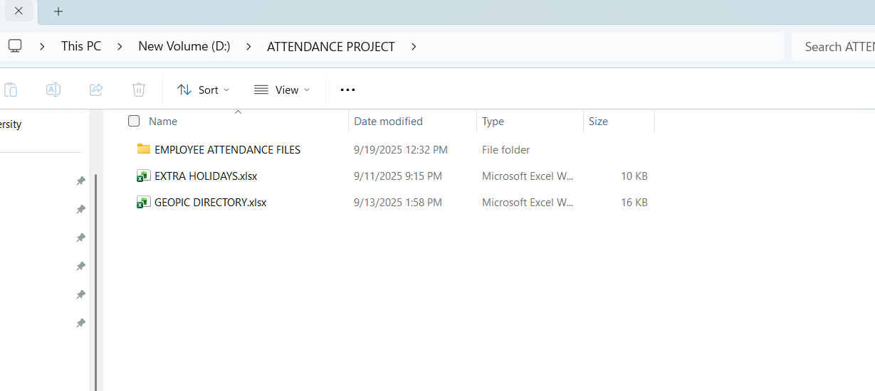
This directory structure enabled a modular automation system — meaning any change in these files (such as adding new attendance sheets, updating employee details, or modifying holidays) was automatically reflected in Power BI upon refresh.

5.2 Data Transformation and Cleaning
The data preparation process was executed entirely within Power Query Editor in Power BI, using the Folder Connection feature.
This allowed all Excel files within the Attendance Folder to be automatically imported, combined, and refreshed without manual reconfiguration.
Key transformation steps included:
Header promotion and data type correction (especially for Date and Time columns).
Text formatting (trimming spaces, converting to uppercase, and standardizing names).
Column refinement — removing redundant columns, renaming for clarity, and reordering fields.
Calculated columns creation:
- Working Hours (based on punch-in and punch-out difference)
- Late Minutes (if punch-in > 9:45 AM for regular shift)
- Attendance Status (Present / Absent / Late)
- Punch Frequency (One-Time or Two-Time)
Data merging between:
- Attendance records
- GEOPIC directory (to isolate valid employees)
- Holiday list (to exclude holidays)
- Late-shift list (to apply alternate shift logic)
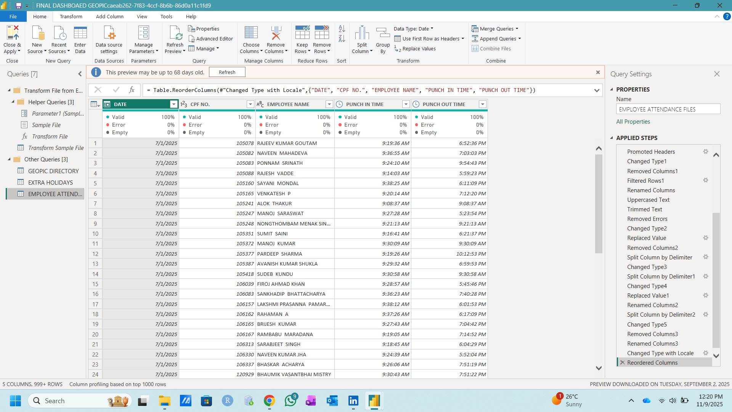
This transformation workflow was completely automated.
Whenever new daily attendance files were added or employee details updated in the directory, Power BI dynamically refreshed the data with a single click on the Refresh button, regenerating all KPIs and visuals in real time.

5.3 Data Model Design
A robust data model was designed to ensure logical relationships and accurate KPI calculations.
The model consisted of five interconnected tables, structured as follows:
- Employee Attendance Table – Contains all daily punch data (for every employee appearing in the attendance files).
- GEOPIC Directory Table – Acts as the master reference table containing official GEOPIC employees only.
- Holiday Table – Stores all non-working days for exclusion in calculations.
- Absent Employees Table – Generated using logic that identifies employees from the GEOPIC directory whose punch data was missing for a given date.
- Date Table – A standard Power BI calendar table for time-based analysis.
- Aggregate Late Summary Table – Summarizes lateness-related metrics (total late punches, total minutes, frequency, etc.) for trend visualization.

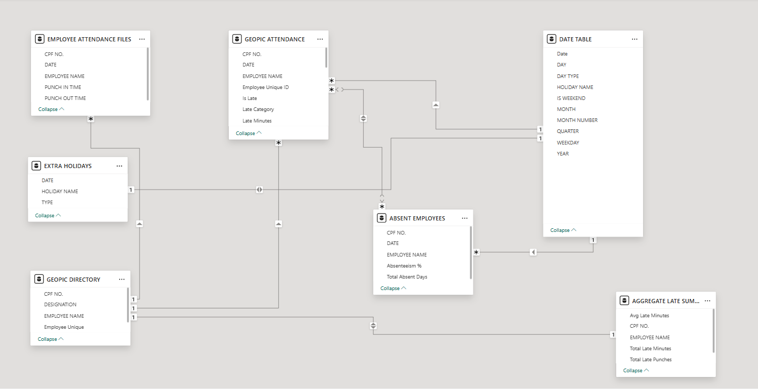
Relationships were built primarily on Employee CPF Number (or Employee ID) and Date, ensuring consistency across all metrics and enabling time-based aggregation and filtering.

5.4 KPI Design and Dashboard Development
The final Power BI report consisted of seven interactive dashboard pages, each designed to analyze different attendance dimensions:
- Lateness Dashboard
KPIs: Total Late Punches, Unique Late Employees, Days Considered, Total Late Minutes, Average Late Minutes, Severe Late Count.
Charts: Top Late Employees by Minutes, Monthly Late Minute Trend, Late Punch by Weekday, Proportion of Late Categories.
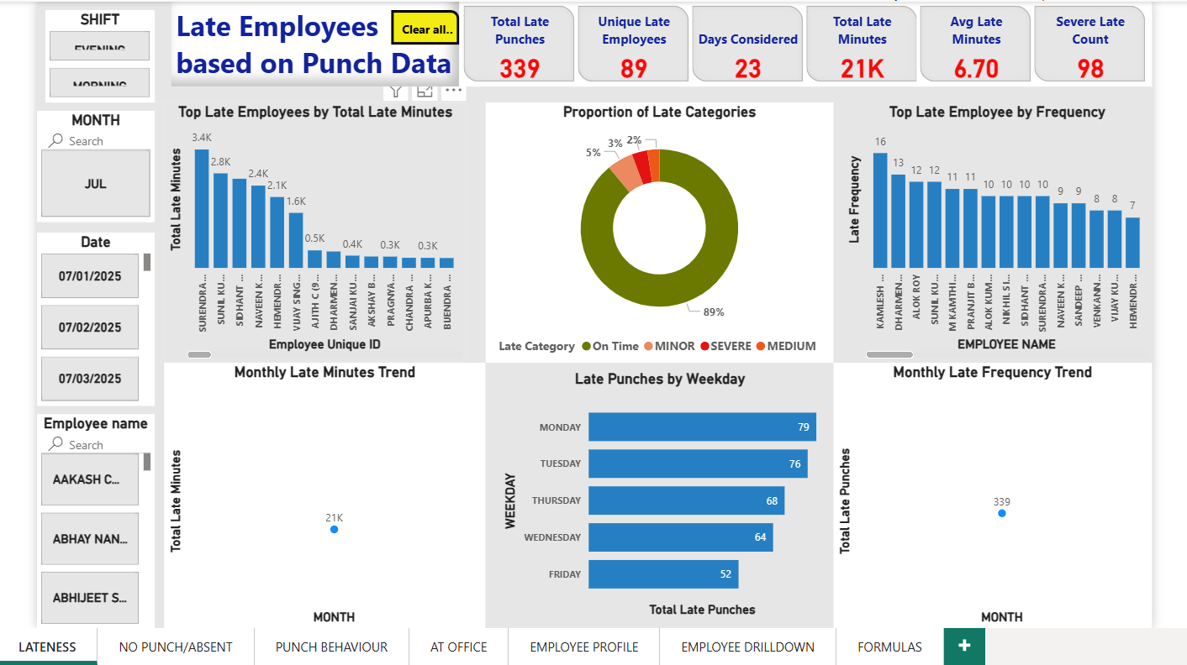
- No Punch / Absenteeism Dashboard
KPIs: Total Absent Days, Distinct Absent Employees, Average Absence per Employee.
Charts: Absenteeism Rate by Weekday, Trend Over Time, Total Absentees by Employee.
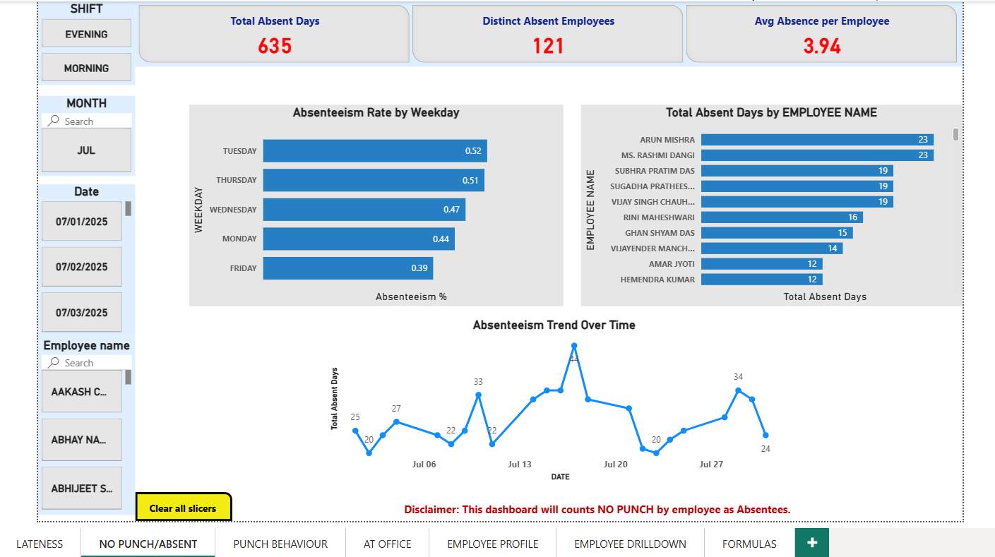
- Punch Behavior Dashboard
KPIs: Total Punches, Unique Employees Punched, One-Time Punch Instances, Two-Time Punches.
Charts: Proportion of One-Time vs Two-Time Punches, Employees with Most One-Time Punches.
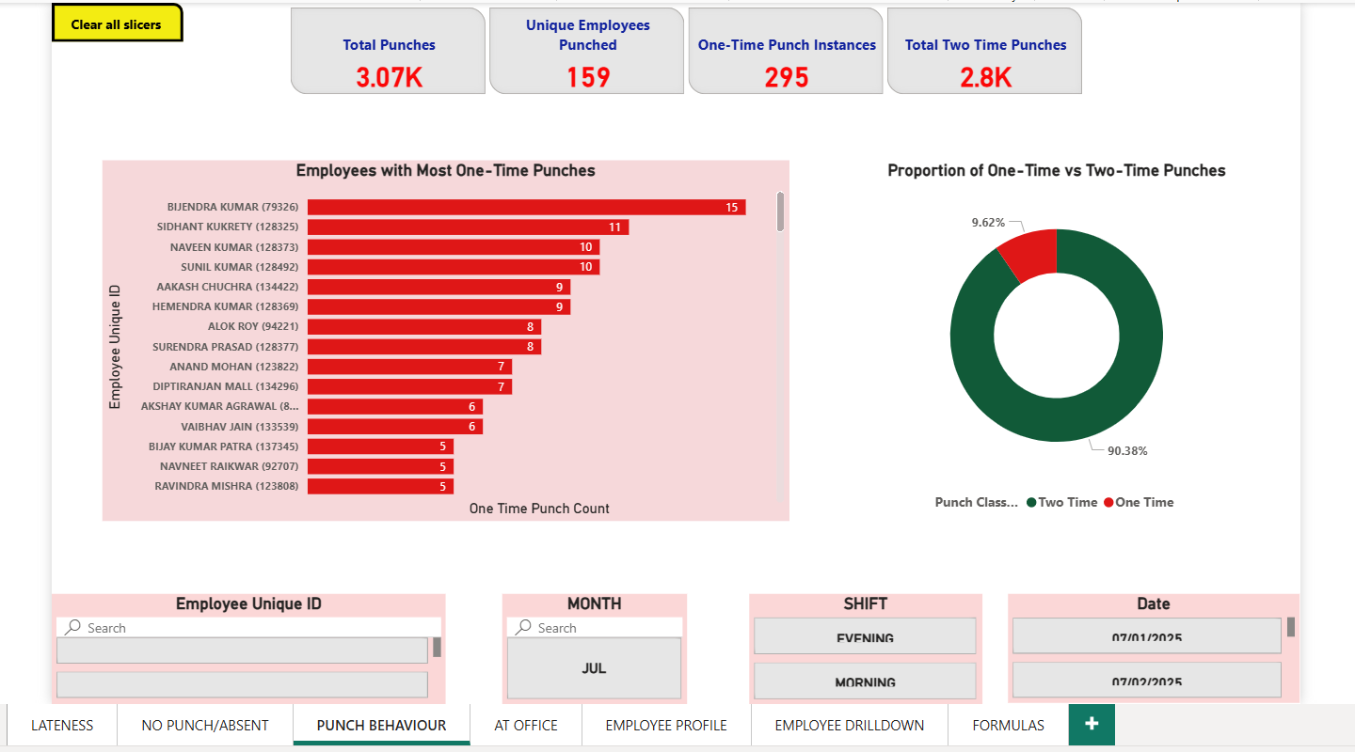
- At Office Dashboard
KPIs: Total Office Hours, Average Hours at Office, Minimum Expected Hours (8 hours).
Charts: Work Hour Distribution, Total Office Hours by Date, Average Work Hours by Employee.
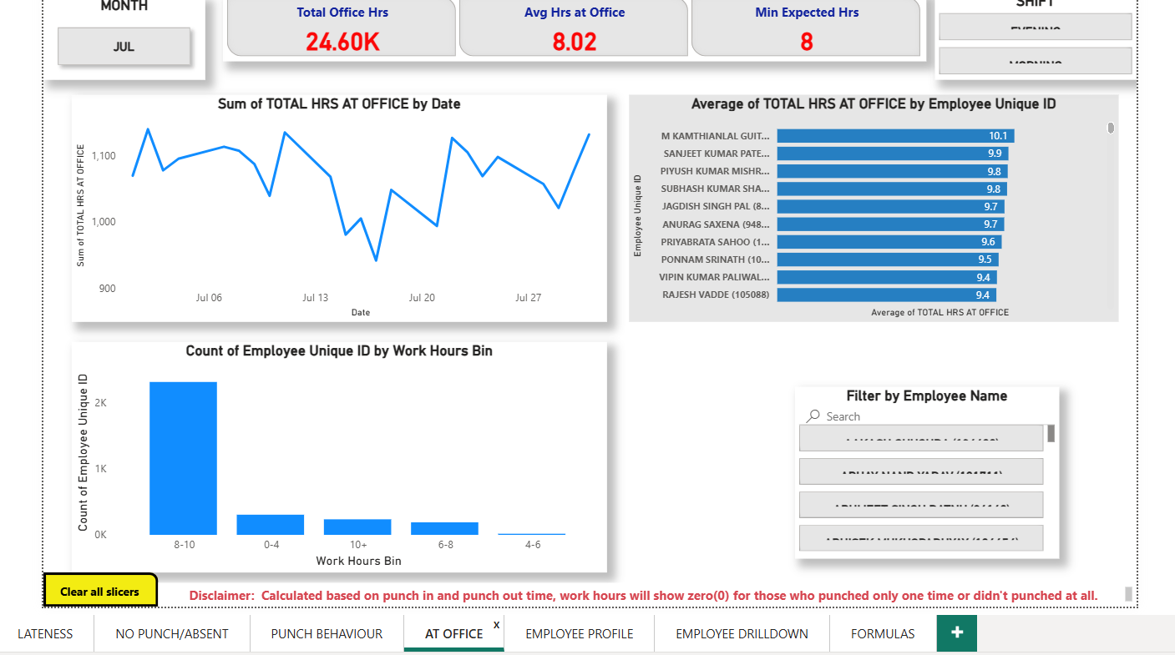
- Employee Profile Page
Displays individual-level summary of total punches, lateness, absenteeism, and working hours, with drill-through filters.
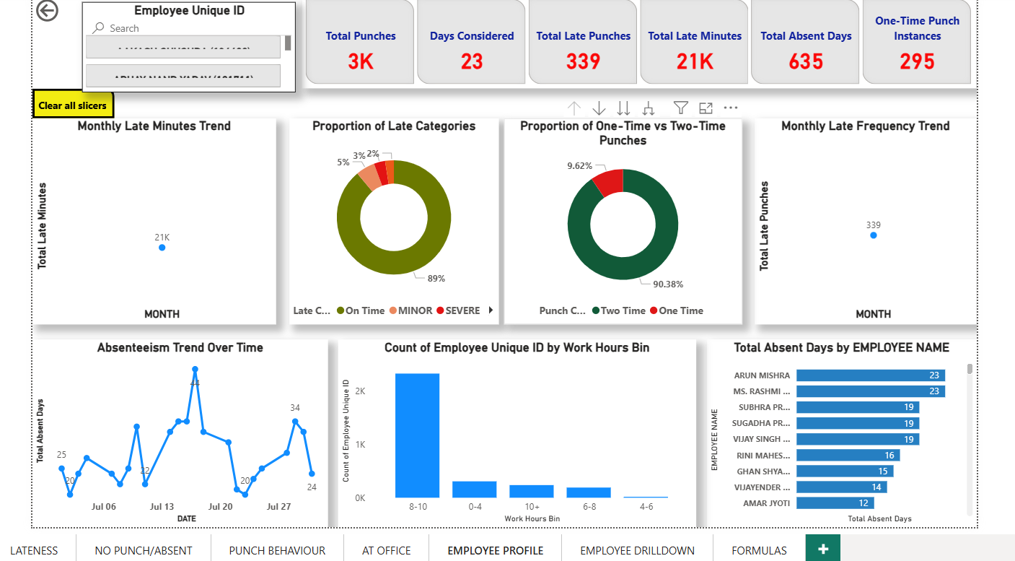
- Employee Drill-Down Page
Enables detailed exploration of employee records, shift patterns, and trends.
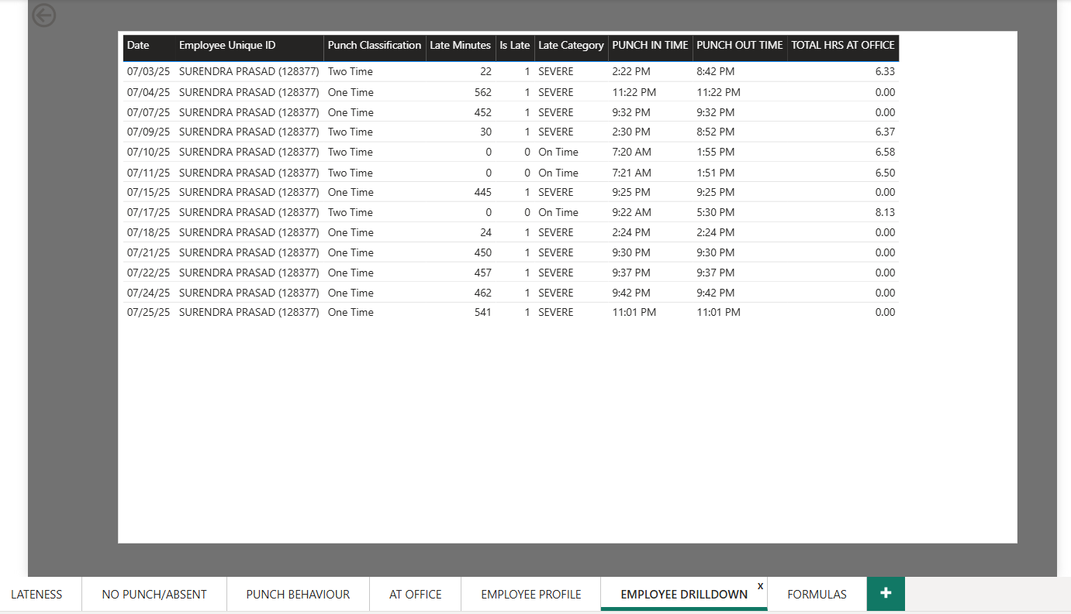
- Formulas Page
Lists DAX-based KPI formulas for transparency and easy future modification.
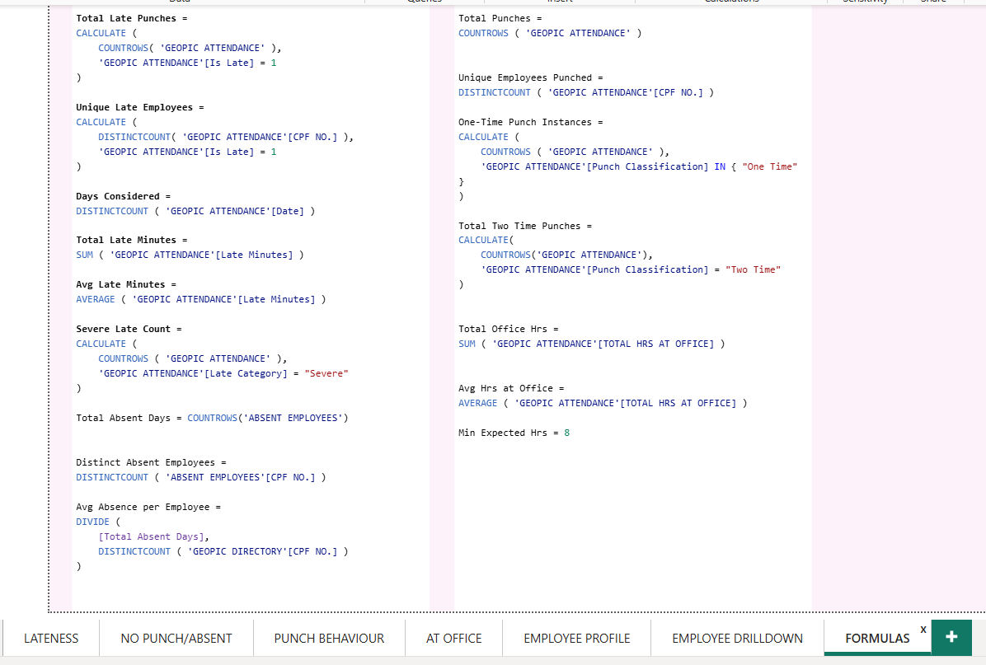
Interactive filters (Employee Unique ID, Month, Shift, and Date) provided multi-dimensional exploration.
Color coding (red for lateness/absenteeism and green for punctuality/attendance) enhanced interpretability.

5.5 Automation Workflow and Impact
The automation workflow was built around a simple yet powerful principle — “Change only in the source directory, not in Power BI.”
This meant that HR or authority members could:
Add or remove employees in the GEOPIC Directory Excel file.
Update holidays or late-shift lists.
Add new daily attendance Excel files to the Attendance Folder.
Once done, a single click on “Refresh” in Power BI Desktop automatically updated all visuals, KPIs, and reports in seconds — no manual steps, no re-imports.
All pages supported CSV export, allowing monthly or individual-level data extraction for record-keeping or review.
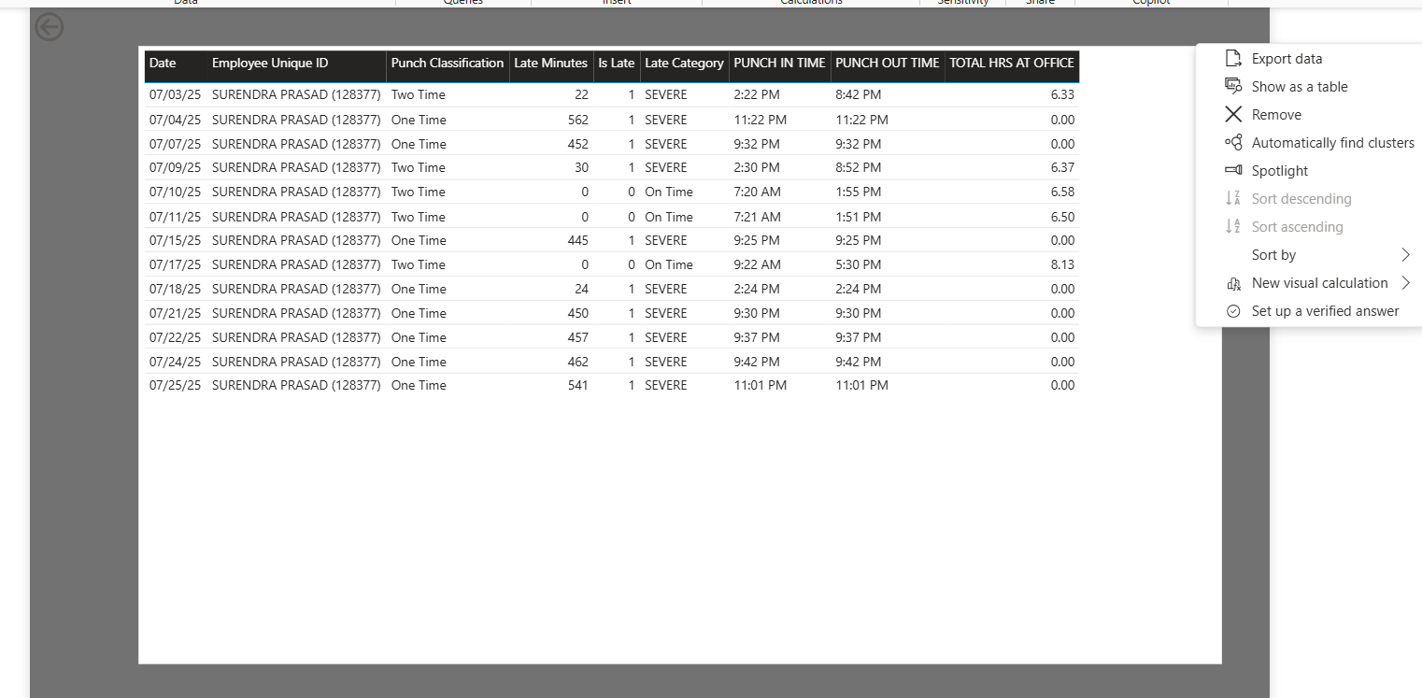
Upon presenting the final report to the GEOPIC authority, the results revealed clear trends in frequent late arrivals, one-time punches, and absentee behavior.
The project led to a policy improvement — installation of a mandatory punch-in/out system at the building entrance, drastically reducing late arrivals and improving attendance discipline.

5.6 Overall Outcome
This real-world project demonstrated the strategic application of data analytics and visualization in operational management.
It showcased how structured data handling, automation, and visualization can translate into organizational efficiency, allowing the GEOPIC authority to monitor employee discipline in real time.
The solution stands as a scalable model for attendance and punctuality monitoring across multiple ONGC departments.

Phase | Action (Input) | Tool/Technique | Outcome (Output)
1. Data Collection | Raw data organized in a central, structured directory. | Folder Structure (D:\Attendance Project) | Four Key Source Files: Daily Attendance, GEOPIC Directory, Holiday List, Late Shift List.
2. Data Transformation | Ingesting and cleaning all source data for consistency and usability. | Power Query Editor | Master Attendance Table with calculated columns for Working Hours, Late Minutes, and Attendance Status.
3. Data Model Design | Establishing logical relationships between all tables. | Power BI Relationships | Star Schema Model: Fact Table (Employee Attendance) connected to Dimension Tables (Directory, Date, Holiday).
4. KPI & Dashboard Development | Creating visualizations and metrics across multiple pages. | DAX Measures & Visualizations | 7 Interactive Dashboards: Lateness, Absenteeism, Punch Behavior, Work Hours, and Employee Detail Pages.
5. Automation & Impact | Ensuring the report can be updated seamlessly with new data. | Refresh Button & Policy Change | Zero-Manual-Steps Automation and organizational impact leading to Policy Improvement (e.g., mandatory punch-in/out).

6. Findings and Results

6.1 Overview
The implementation of the automated attendance analysis system at GEOPIC, ONGC Dehradun brought a significant transformation in monitoring and managing employee punctuality and attendance trends.
Before the project, the process was manual, unstructured, and reactive, with no consolidated reporting system, no trend analysis, and no systematic tracking of defaulters or absentees. Multiple shifts, irregular punch timings, and scattered Excel sheets made data consolidation and insight generation highly time-consuming.

6.2 System Automation and Performance
The deployment of a Power BI-based automated dashboard converted the entire attendance monitoring process into a real-time, dynamic, and data-driven system.
The report could now be refreshed with a single click, updating all KPIs and visuals within approximately 10 seconds.
All data cleaning, transformation, and KPI calculations were embedded within Power BI, completely eliminating manual report preparation and file-level data merging.

6.3 Structured Data Directory and Workflow
A major achievement of the project was the creation of a structured and interlinked data directory, ensuring zero inconsistencies or loopholes.
The master directory (D Drive) comprised four synchronized components:
- Attendance Sheets – Daily raw punch-in and punch-out records
- GEOPIC Employee Directory – CPF numbers, names, and designations
- Holiday File – List of official holidays and weekends
- Late-Shift File – Timing logic for employees in special shifts
Any updates—such as adding or removing attendance sheets, modifying holidays, or updating employee details—were made directly in the source folders. Upon refreshing, the Power BI report automatically integrated the updated data, maintaining continuous accuracy and consistency.

6.4 Data Model Design
A robust and logical data model was developed, comprising interconnected tables:
- Employee Attendance
- GEOPIC Directory
- Holidays
- Absent Employees
- Date Table
- Aggregate Late Summary
This model enabled seamless time-based analysis, relationship management, and trend reporting.
Automated DAX calculations identified employees with missing punches, computed late minutes (after 9:45 AM for regular shifts and 2:00 PM for late shifts), and categorized attendance status as Present, Late, or Absent.

6.5 Impact and Organizational Outcomes
Following the system’s implementation, overall employee punctuality improved by nearly 80% over the next few months.
Key behavioral and managerial outcomes included:
- Reduced late arrivals and minimized one-time punches.
- Higher accountability, as employees could now view individual attendance insights.
- Improved data transparency and monitoring across all shifts.
These findings led the GEOPIC authority to introduce policy-level improvements such as:
- Mandatory biometric punch barrier installation to record both entry and exit times.
- Automated alerts for repeat defaulters, helping supervisors take corrective actions.
- Stricter attendance policy, linking punctuality directly with professionalism and performance appraisals.

6.6 Technical and Analytical Achievements
The project demonstrated strong technical execution, including:
- Data modeling and DAX formula creation for advanced KPI logic.
- Power Query transformations for cleaning and standardizing raw punch data.
- Automation workflow design enabling fully self-updating dashboards.
This experience provided practical exposure to handling live organizational data, defining business-oriented KPIs, and translating operational requirements into analytical models within a business intelligence platform.

6.7 Presentation and Recognition
The final Power BI dashboard was presented before the employees, Executive Director and Senior Programming Officer of GEOPIC, where its real-time automation, logic-driven KPIs, and visual analytics were demonstrated.
The system received highly positive feedback for its ability to:
- Generate accurate insights instantly,
- Support data-backed decisions, and
- Simplify attendance monitoring across departments.

6.8 Summary
In conclusion, the project successfully delivered a strong, scalable, and fully automated attendance monitoring system that resolved earlier inefficiencies.
It introduced real-time data handling, improved punctuality and accountability, and enhanced managerial decision-making.
The framework established at GEOPIC serves as a replicable model for other ONGC departments, integrating automation, analytics, and governance into a unified reporting ecosystem.

7. Conclusion and Future Scope

7.1 Conclusion
The internship project at GEOPIC, ONGC Dehradun, marked a significant achievement in transforming manual attendance management into a fully automated, insight-driven system using Microsoft Power BI. The solution not only streamlined attendance tracking but also introduced a culture of data-driven decision-making within the organization.
Prior to implementation, attendance records were decentralized and time-consuming to analyze. By integrating multiple Excel-based attendance sources, employee directories, and holiday lists into a single automated workflow, the project successfully eliminated manual dependencies and reporting delays. The new system provided instant updates within seconds, allowing HR and management teams to visualize trends, track punctuality, and identify absentee patterns with complete accuracy.
The results were both measurable and behavioral. Employee punctuality improved by nearly 80%, and the new system ensured zero loopholes in attendance recording. Policy interventions—such as the installation of a biometric punch barrier, mandatory dual punch records, and alert notifications for repeat defaulters—were direct outcomes of insights derived from the dashboard. These changes led to greater accountability, transparency, and operational discipline across the department.
The project also provided the intern with hands-on exposure to data analytics and business intelligence, covering Power Query transformations, data modeling, DAX calculations, report automation, and professional presentation of analytical insights to senior leadership. It served as a practical demonstration of how analytical tools can optimize real-world administrative processes.

7.2 Future Scope
While the system has proven effective and scalable within GEOPIC, there are several potential areas for further enhancement and extension:
- Integration with Real-Time Databases: Connecting Power BI directly to ONGC’s central biometric or ERP database would allow live data refreshes without file-level imports.
- Role-Based Dashboards: Developing access-specific dashboards for HR, department heads, and executives can enable customized insights and control.
- Email or Power Automate Alerts: Automating notifications for frequent latecomers or absentees through Power Automate or Outlook integration.
- Predictive Analytics: Incorporating predictive models to forecast absenteeism trends or peak late days based on historical patterns.
- Enterprise-Level Scalability: Expanding the same framework to other ONGC centers and integrating cross-departmental comparisons for benchmarking.
- Mobile Power BI App Integration: Allowing real-time monitoring through mobile dashboards for senior officials and HR staff on the go.

7.3 Summary
In essence, the project demonstrated how data analytics and visualization can drive organizational efficiency, policy improvement, and behavioral transformation. The system developed at GEOPIC stands as a benchmark for digital transformation within ONGC—offering scalability, sustainability, and a roadmap for future automation-driven governance.

